PROJECT

Name: Shubham Pandey

Email id: [pandeyshubham6720@gmial.com](mailto:pandeyshubham6720@gmial.com)

**Topic**

Development of Server Monitoring Tools

**Program:**

1. **Source Code:**

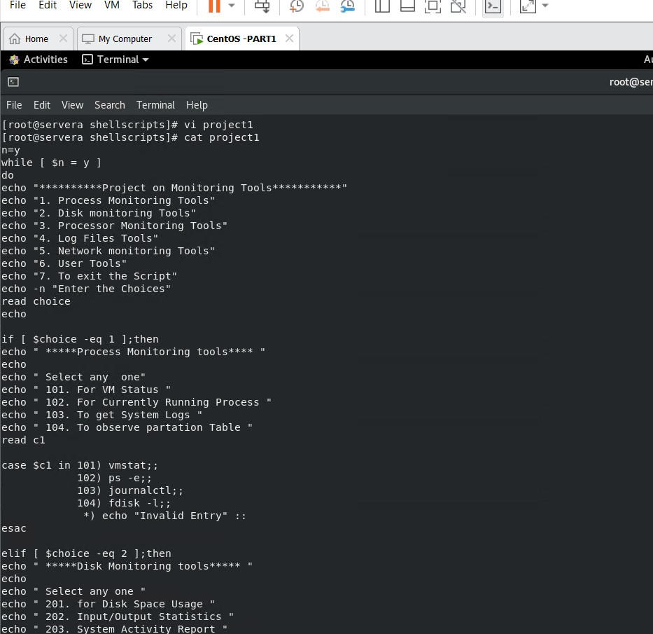

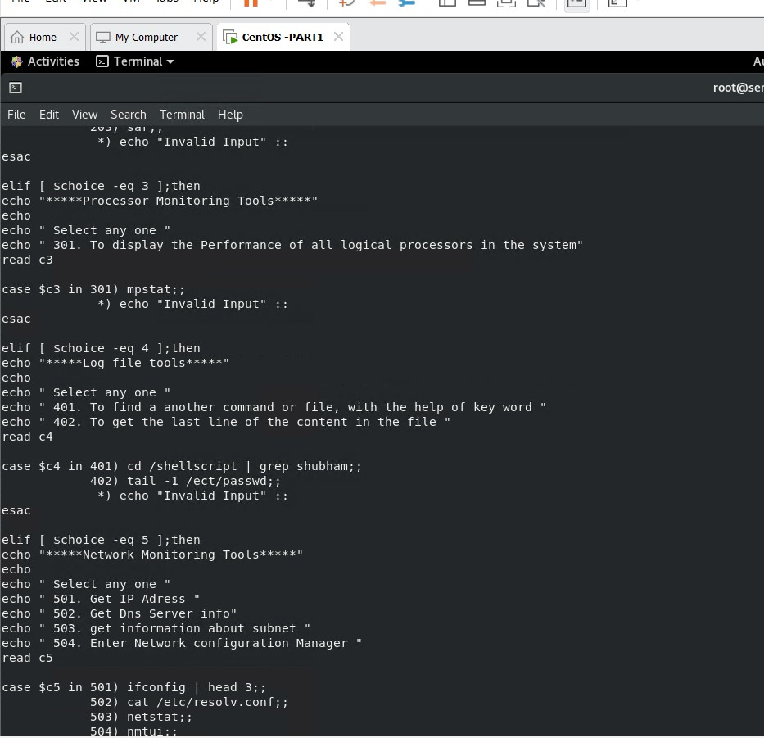

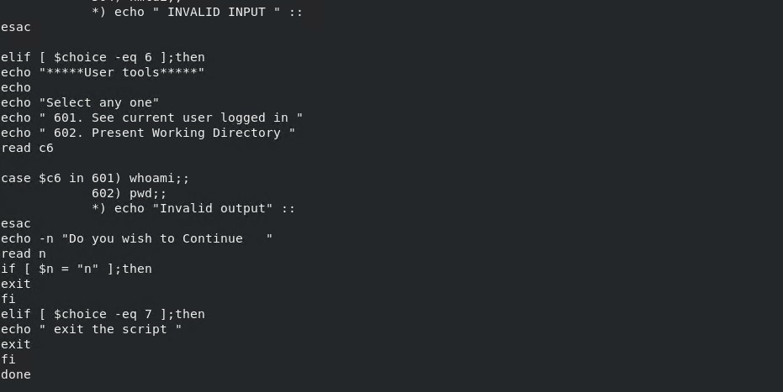

1. **Outputs:**

* **Process monitoring tools:**

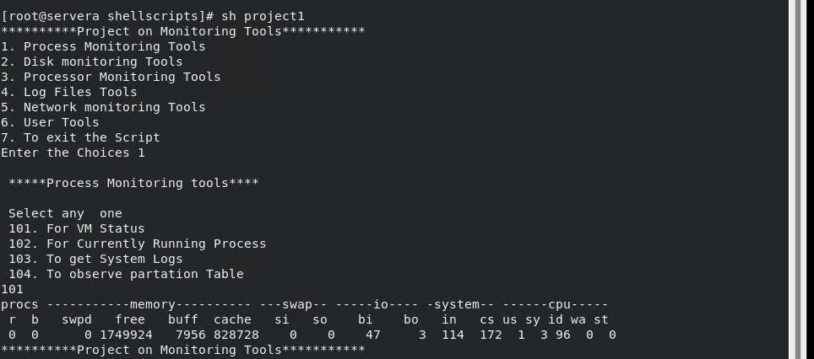

* **Disk monitoring Tools**

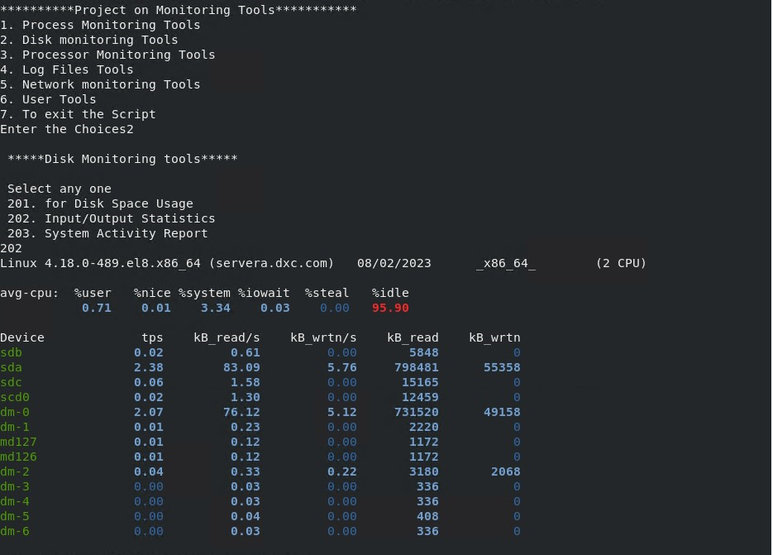

* **Processor Monitoring Tools**

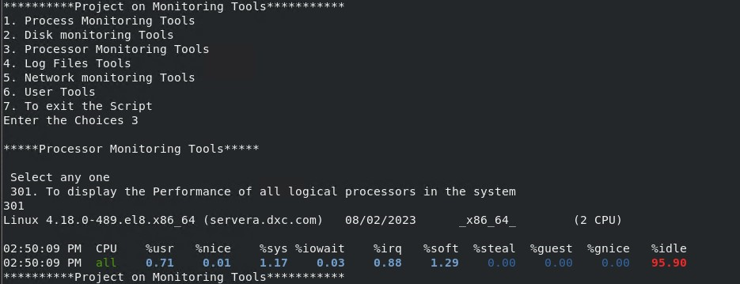

* **Network Monitoring Tools**

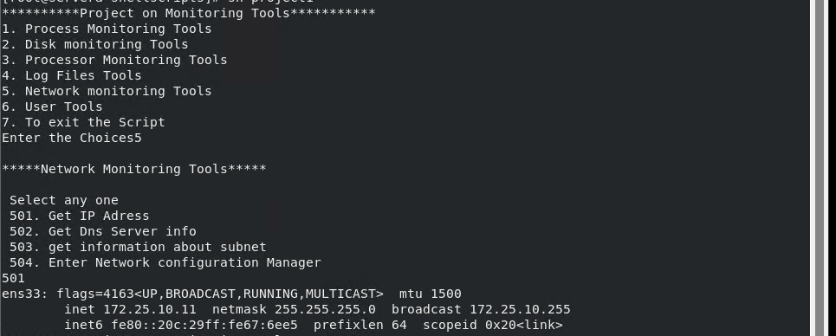

* **User Tools**

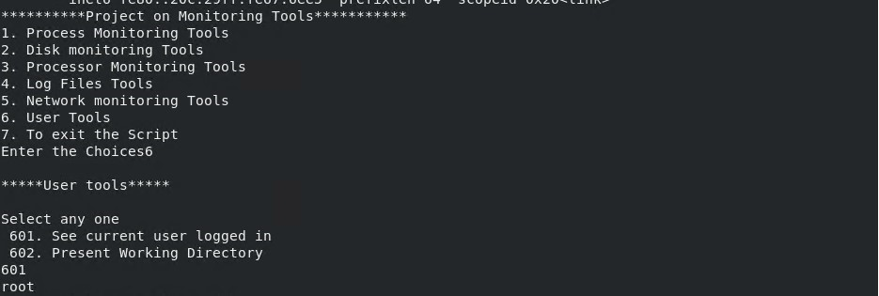

* **To Exit**

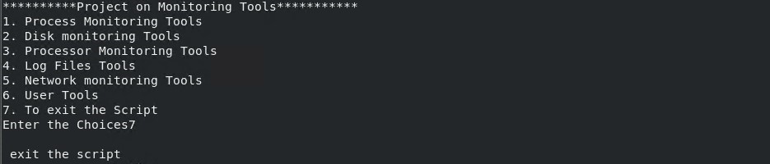

**The End.**